Animal Farm: In-Class Project  
50 points

**Characterization:**

1. Define **Characterization**:
2. George Orwell characterizes Napoleon, Snowball, and Squealer as three different types of leaders, each with positive and negative traits. In each blank, write down one positive trait and one negative trait of each pig. Then, underneath the traits cite an incident, action, or speech that illustrates each characteristic.   
    Positive Negative

Napoleon  
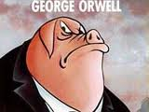

3. Choose another character from the story and give examples of characterization from the story using the blanks below:  
Name of character:  
Example of characterization through actions:  
  
Example of characterization through what others say about him/her:  
  
 **Conflict:**

Squealer  
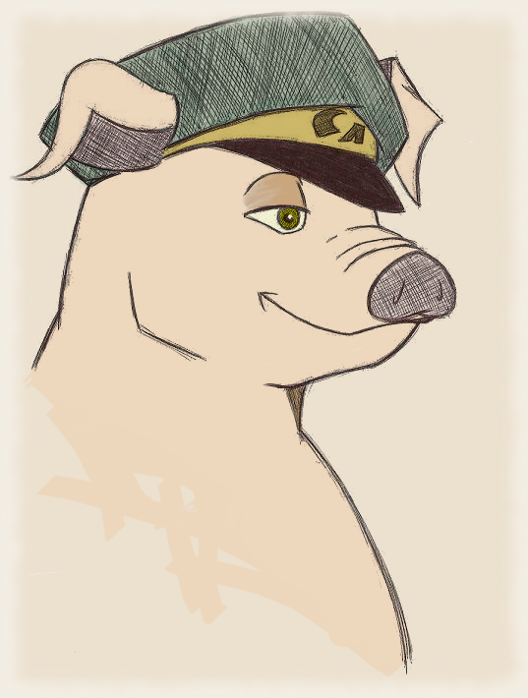

Snowball  
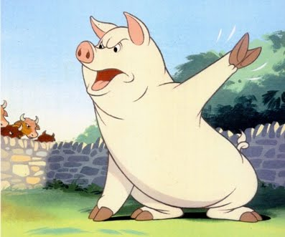

1. Which do we see more of in Animal Farm: internal or external conflict?
2. After the execution of many animals, describe the conflict Clover has within herself as she and the other animals look over the farm.
3. Conflict can take one of the following forms: (1) Character vs. another character, (2) character vs. society, (3) a character vs. nature, or (4) a character vs. him or herself In the chart below, identify the kind of conflict involved, the causes of the conflict, and the outcomes of the conflict.

Napoleon disagrees with Snowball’s plans for the windmill.   
Type of conflict:

The animals struggle with how to break up the stones to build the windmill  
Type of conflict:

Clover confronts Mollie about Mollie’s contact with humans.   
Type of conflict:

**Fable:**

1. Define **fable:**
2. What human trait is exhibited when the animals celebrate expelling Jones from the farm?
3. Consider lessons learned by the animals of Animal Farm and by you as a reader of Animal Farm. Write a very short fable about one of the lesson in the space provided, creating your own characters and setting to convey the message. State the lesson learned at the end of the fable.

______________________________________________________________________________  
  
______________________________________________________________________________  
  
______________________________________________________________________________  
  
______________________________________________________________________________  
  
______________________________________________________________________________  
  
______________________________________________________________________________  
  
______________________________________________________________________________  
  
______________________________________________________________________________  
  
______________________________________________________________________________  
  
______________________________________________________________________________  
  
______________________________________________________________________________  
  
______________________________________________________________________________  
  
**Satire**  
  
10. Define **satire:**11. Explain how George Orwell uses satire to criticize human vanity through the horse Mollie:  
  
12. Explain how George Orwell uses satire to criticize something through either the pigs or the sheep:  
  
**Foreshadowing**13. Define foreshadowing:

14. Using the graphic organizer below, explain how the passage provided foreshadows a future event in the novel.

15. Re-read Old Major’s speech. What are two more events or actions foreshadowed in that passage?

**Symbolism**

16. Define **symbolism:**

17. When we began reading Animal Farm, we filled out character charts about what different animals symbolized in the story. Now, look at the following items and tell what they might symbolize for the animals on the farm:  
The Green Flag:  
The pigs walking on two legs:  
The name “Manor Farm”:  
  
18. Choose one of the following events in the story and, using either a book or website, answer the questions that follow. Circle or highlight the event you choose.   
The trials of the animals, the windmill, the special pig committee presided over by Napolean, the revolt of the hens  
  
Name of the book or website I found this:___________________________________________________  
What it symbolizes:_____________________________________________________________________  
_____________________________________________________________________________________  
My reaction: __________________________________________________________________________  
_____________________________________________________________________________________  
  
**Irony**  
  
19. Define **irony:**  
20. What is ironic about the fact that Napolean introduces “Spontaneous Demonstrations” and orders that they be held every week?  
  
21. Using the graphic organizer below, identify whether the passages are verbal, dramatic, or situational irony, and explain the irony in each passage.

|  |  |  |
| --- | --- | --- |
| Passage | Type of Irony | Explanation |
| “They were happy in their work; they grudged no effort or sacrifice, well aware that everything that they did was for the benefit of themselves and those of their kind…and not for a pack of idle, thieving human beings.” |  |  |
| “Then there were lamp oil and candles for the house, sugar for Napoleon’s own table (he forbade this to the other pigs, on the ground that it made them fat)…” |  |  |
| “Out of spite, the human beings pretended not to believe that it was Snowball who had destroyed the windmill…The animals knew this was not the case” |  |  |

**Propaganda**22. Define **propaganda:**  
  
23. Spreading rumors can be an effective propaganda technique. Give three examples of how rumors are used to distort truths about Fredrick or Snowball (or both). Explain why someone might spread the rumors.   
  
1.  
  
2.   
  
3.  
  
24. Pretend you are a pig on Animal Farm. You know how to read and write, and you have been given the task of creating a propaganda poster for the farm. Design a poster in the space provided, and tell what message you are sending in the poster. For full credit, take up the entire space.   
Example:



Foil  
Moral  
Allegory  
Themes